CS 499 Module One Assignment Template

Complete this template by replacing the bracketed text with the relevant information.

- Self-Introduction: Address all of the following questions to introduce yourself.

  - How long have you been in the Computer Science program?
I have been in the Computer Science program since 2023.

  - What have you learned while in the program? List three of the most important concepts or skills you have learned.
I have learned a lot since I’ve started getting my degree. I would say the top three concepts or skills I have learned is programming and debugging my programs, project management, and computer graphics design.

  - Discuss the specific skills you aim to demonstrate through your enhancements to reach each of the course outcomes.
I aim to demonstrate specific skills through my enhancements for this project. My main focus is to provide more detail to my project by using my project management, computer graphics design, and programming skills. This project is a great opportunity to show how my programming and computer graphics design skills have improved. I also will be using my project management skills to determine my requirements, deadlines, needed tools, and what the finished product should be.

  - How do the specific skills you will demonstrate align with your career plans related to your degree?
These specific skills align with my career plans related to my degree. My desire career is to work for a gaming company however, I would also like to have some experience working in IT. These skills are the foundation for both these careers. Being able to determine a projects’ requirements and objectives is extremely important for the creation of any product. Programming is also a foundation in both careers. Having knowledge and the skills to work with multiple programming languages allows for more flexibility and variety when it comes to developing and designing projects. While computer graphics design is imporant for game design. Understanding how to recreate object from scratch and the ability to create unique designs that stand out allow for visual pleasing game design.

  - How does this contribute to the specialization you are targeting for your career?
This project will be a good example of my specialization for my career. I want to show case my ability to not only manage projects and create programs that are functional and efficient but also my creativity and knowledge of computer graphics and design.

- ePortfolio Set Up:

  - Submit a screen capture of your ePortfolio GitHub Pages home page that clearly shows your URL.
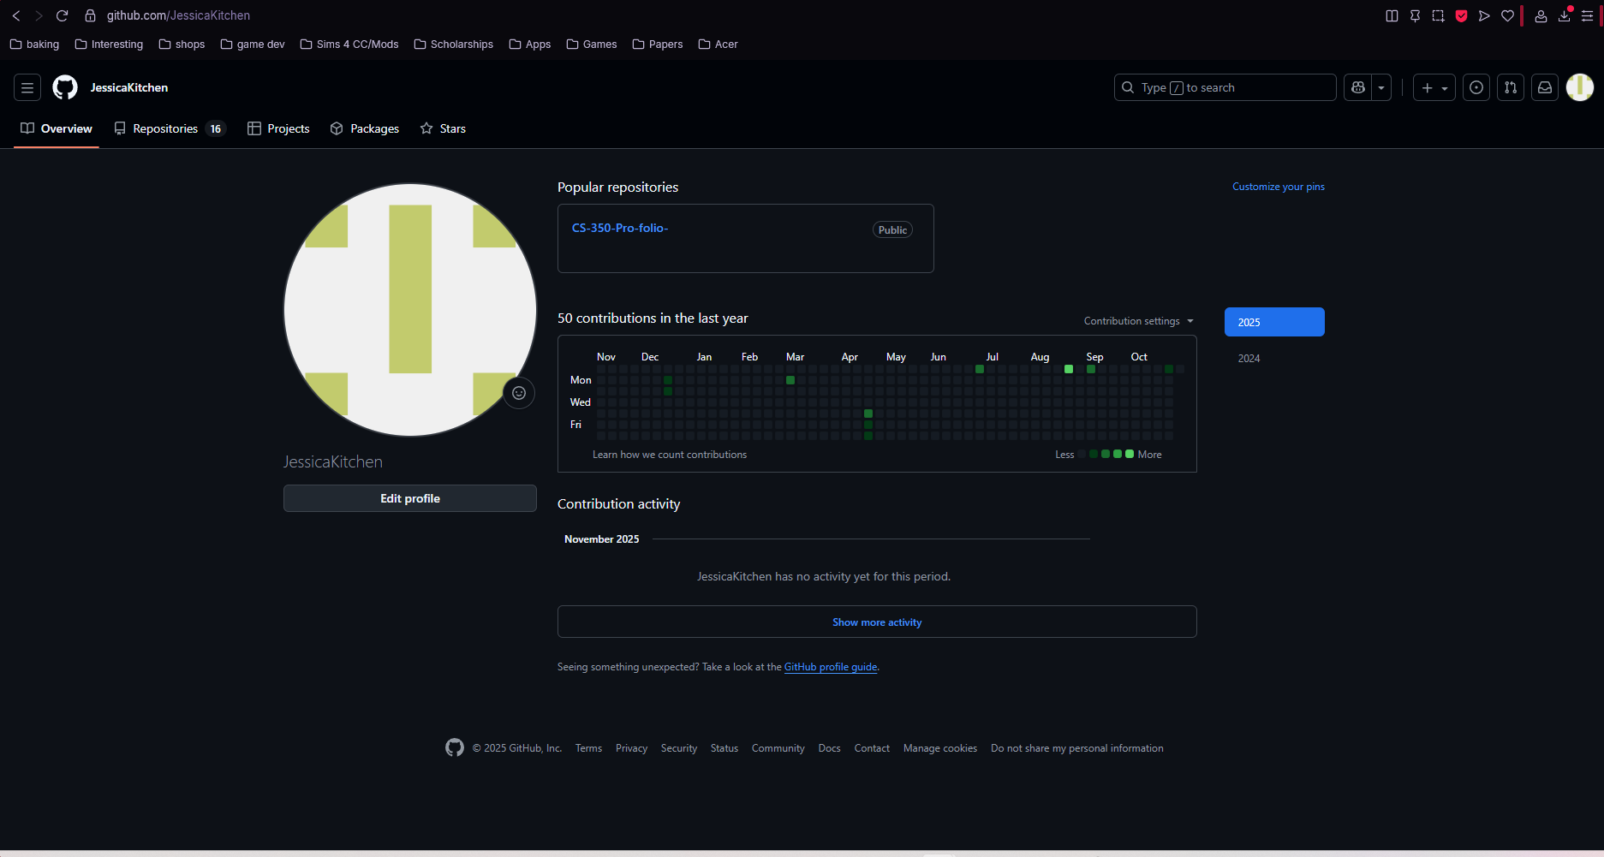
    - You already have a repository in GitHub where you uploaded projects in previous courses. Your ePortfolio will reside in GitHub but can link to work at other sites, such as Bitbucket.

  - Use the GitHub Pages link in the Resource section for directions on:
    - How to create your GitHub website and publish code to GitHub Pages
    - Issues, such as adding links to other sites

  - Paste a screenshot of your GitHub Pages home page with your URL clearly showing in the space below.

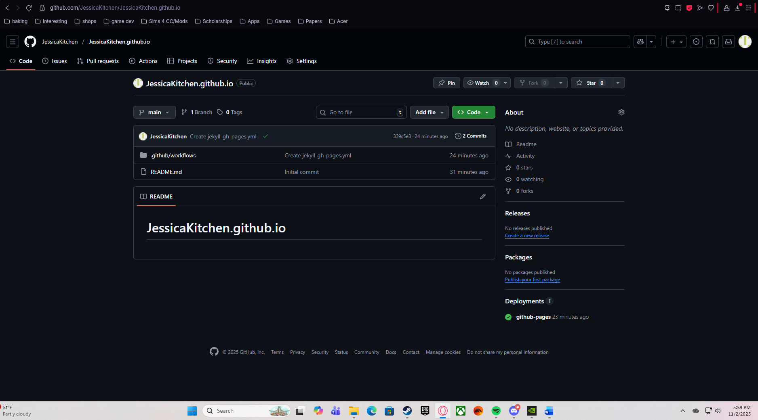
- Enhancement Plan:

  - Category One: Software Engineering and Design
    - Select an artifact that is aligned with the software engineering and design category and explain its origin. Submit a file containing the code for the artifact you choose with your enhancement plan.

The selected artifact for this project is CS 330: Computational Graphics and Visualization. The original concept was an assignments that allowed for the class to recreate a scene with objects in it. The scene that I choose to recreate was my gaming desk setup.

Note: Your artifact may be work from the following courses:

- IT 145: Foundation in Application Development
- CS 250: Software Development Lifecycle
- CS 260: Data Structures and Algorithms
- IT 315: Object Oriented Analysis and Design
- CS 320: Software Testing, Automation, and Quality Assurance
- CS 330: Computational Graphics and Visualization
- CS 340: Advanced Programming Concepts
- CS 350: Emerging Systems Architectures and Technologies
- CS 360: Mobile Architecture and Programming
- IT 365: Operating Environments
- IT 380: Cybersecurity and Information Assurance
- CS 405: Secure Coding
- CS 410: Reverse Software engineering
- IT 340: Network and Telecommunication Management
- IT 380: Cybersecurity and Information Assurance

    - Describe a practical, well-illustrated plan for enhancement in alignment with the category, including a pseudocode or flowchart that illustrates the planned enhancement.

To enhance my original project for OpenGL, I plan on adding more detail to my desktop environment and refining the objects that are already created. The goal is to create more detailed and intricate objects that appear to be more realistic and showcase more complexities of the desktop environment. I also plan on using more high-resolution textures for the objects to create a more realistic environment. As well as implementing a more realistic lighting environment that better reflects the desktop environment. This will include illumination and reflections when needed to make the environment more immersive. I also plan on implementing basic animation to add more interactivity and demonstrate my technical skills. These enchantments will demonstrate my creativity as well as my proficiency in using industry-standard tools and techniques in 3D graphics and visualization.

For this category of enhancement, consider improving a piece of software, transferring a project into a different language, reverse engineering a piece of software for a different operating system, or expanding a project’s complexity. These are just recommendations. Consider being creative and proposing an alternative enhancement to your instructor.

Think about what additions to include to complete the enhancement criteria in this category. Since one example option is to port to a new language, that is the kind of scale that is expected. This does not mean you need to port to a new language but instead have an equivalent scale of enhancement. Underlying expectations of any enhancement include fixing errors, debugging, and cleaning up comments, but these are not enhancements themselves.

    - Explain how the planned enhancement will demonstrate specific skills and align with course outcomes.

      - Identify and describe the specific skills you will demonstrate that align with the course outcome.

The planned enhancement for the original project is to expanded the project’s complexity by demonstrating multiple specific skills that align with the courses outcomes.

First, I will showcase my ability to create detailed and intricate geometry. That will create a more realistic and complex design and environment. This skill aligns with the course outcome of developing proficiency in techniques used for computational graphics. I will review the original desktop environment and determine where more detail needs to be added. These objects will become more complex which will demonstrate a deep understanding of 3D modeling principles and techniques.

Secondly, high-resolution textures and shading techniques will be used to highlight my texturing and lighting skills. This aligns with the course outcome of enhancing 3D scenes using realism and visual detail. UV wrapping and various shading methods will be used to create more lifelike textures, and realistic lighting effects such as global illumination and reflections. This will demonstrate my ability to enhance the visual fidelity of the scene.

Finally, basic animation as well as improved camera navigation will be incorporated to showcase my skills in creating environments that are interactive and dynamic. This aligns with the courses outcome of developing graphics applications that are interactive. By introducing animations and refining camera controls, I will be demonstrating my skills in adding interactivity to 3D scenes which will ensure that the user experience is smooth and engaging.

Overall, these enchantments wil improve the projects functional aspects as well as the the overall aesthetic. In addition to this, it will also demonstrate my improved skills in computational graphics and visualization, which aligns with the courses outcomes.

Pseudo code:
- Review desktop scene determine where more detail needs to be added
- Implements high-resolution textures and shading techniques, determine where lighting source should located at and what reflections are needed.
- Use UV wrapping and shading methods to create more lifelike textures and realistic lighting.
- Introduces animations on specific object such as monitor turning on or mouse moving across the table.
- Performing final testing

      - Select one or more of the course outcomes below that your enhancement will align with.

My enchantments for my original OpenGL project will align with the following course outcomes:

Design, development, and deliver professional quality communications that are coherent, technically sound, and adapted to specific audiences and context.

By creating more detailed and realistic models and applying high-resolution textures, implementing realistic lighting, and incorporating animations, and improved camera navigation. I will demonstrate my ability to create 3D scenes that are visually compelling and are technically sound. This aligns with the course outcomes of delivering professional-quality visual communications. The documented design decisions that are enhanced with comprehensive explanations and visual aids, ensure that the project is coherent and can be adapted to both technical and nontechnical audiences.

Showcases ability to use innovative techniques, skills, and tools in computing practices to implement computer solutions that can deliver value and accomplish specific industry goals.

I plan to implement advance features and improve the overall quality of the 3D scene. This will demonstrate my ability to use tools that are industry standard to create high-value, professional projects. This aligns with the course outcome of meeting industry-specific goals by implementing computer solutions.

By focusing on these outcomes, these enchantments will improve the project’s visual aesthetic and functional aspects. It will also demonstrate my improved skills in computational graphics and visualization.

Course Outcomes:

- Employ strategies for building collaborative environments that enable diverse audiences to support organizational decision-making in the field of computer science.
- Design, develop, and deliver professional-quality oral, written, and visual communications that are coherent, technically sound, and appropriately adapted to specific audiences and contexts.
- Design and evaluate computing solutions that solve a given problem using algorithmic principles and computer science practices and standards appropriate to its solution while managing the trade-offs involved in design choices.
- Demonstrate an ability to use well-founded and innovative techniques, skills, and tools in computing practices for the purpose of implementing computer solutions that deliver value and accomplish industry-specific goals.
- Develop a security mindset that anticipates adversarial exploits in software architecture and designs to expose potential vulnerabilities, mitigate design flaws, and ensure privacy and enhanced security of data and resources.

  - Category Two: Algorithms and Data Structures

- Select an artifact that is aligned with the algorithms and data structures category and explain its origin. Submit a file containing the code for the artifact you choose with your enhancement plan. You may choose work from the courses listed under Category One.

My CS 330 project aligns with category two through the efficient use of methods and algorithms that provide graphics with more visual depth as well as optimizing the algorithms to improve performance. These algorithms are employed to ensure the program runs smoothly and can be rendered efficiently. The project emphasizes both design and testing of data structures and algorithms.

- Describe a practical, well-illustrated plan for enhancement in alignment with the category, including a pseudocode or flowchart that illustrates the planned enhancement.

I plan to optimize the existing program by introducing more efficient algorithms and by improving the data structures for better performance and scalability. A key enhancement will be to use specialized shaders and avoid conditionals. This enchancement will improve the GPU-side of optimization. These enchantments will allow for the shader program and data access to run as fast as possible. In addition to this, I will also implement batching draw calls and minimize state changes. This will improve the CPU-side of optimization which will reduce time spent issuing commands and preparing data.

Overall, I plan on boosting my OpenGL projects performance and rendering. This should improve optimization on both the GPU and CPU sides. Allowing for a better performance and more efficient program.

Pseudo Code:
        - Review existing code
        - Determine where optimization should occur
        - Implement specialized code for CPU-side
        - Implement specialized code for GPU-side
        - Test enchancements
        - Deploy and end

For this category of enhancement, consider improving the efficiency of a project or expanding the complexity of the use of data structures and algorithms for your artifact. These are just recommendations. Consider being creative and proposing an alternative enhancement to your instructor. Note: You only need to choose one type of enhancement per category.

Think about what additions to include to complete the enhancement criteria in this category. Since one example option is to port to a new language, that is the kind of scale that is expected. Perhaps you might increase the efficiency and time complexity of an algorithm in an application and detail the logic of the increased time complexity. Remember, you do not need to port to a new language but instead have an equivalent scale of enhancement. Underlying expectations of any enhancement include fixing errors, debugging, and cleaning up comments, but these are not enhancements themselves.

- Explain how the planned enhancement will demonstrate specific skills and align with course outcomes.

  - Identify and describe the specific skills you will demonstrate to align with the course outcome.

The planned enchancement demonstrates a variety of specific skills that align with the course outcomes. Especially, in terms of applying algorithms and data structures to solve complex problems efficiently. Using batch draw calls to combine geometry as much as possible into single buffers. The OpenGL project will be better optimized and will be able to render the scene with a few large calls instead of multiple small ones. This directly supports the course outcome of understanding and applying algorithms and data structures to enhance software performance as well as scalability.

In addition to this, I will also minimize state changes since switching between different states is costly for the driver and hardware. This will be done by grouping together objects that share the same shader program, textures, and other OpenGL states. This ensures that system will meet the requirements for both functionality and efficiency. Which reflects the course outcome of applying appropriate algorithms to manipulate and process data.

While avoiding conditionals will minimize the chances of branches being executed on some hardwares. And the use of specialize shaders will be done with many small shaders rather than a few large shaders. This will improve the optimization for the shaders and will increase the overall performance of the program. This will demonstrate my ability to focus on two sides of a program for optimization and performance. It will also help showcase my project management skills side there are two sides of the program that need to be improved upon.

These skills directly align with the course outcomes of applying algorithms that are effective and optimizing software through data structures which will develop a software system that is user friendly.

  - Select one or more of the course outcomes listed under Category One that your enhancement will align with.

The following enhancements align with the course outcomes from category one:

Design and evaluate computing solutions that can solve a given problem using algorithmic principles as well as computer science practices and standards that are appropriate to the solution while being able to manage potential trade-offs that are involved in the design choices.

This enchancement aligns with the course outcome by incorporating batch draw calls and grouping object together to optimize the program. These enchancements are aimed at improving the efficiency and scalability of the program. It does involve evaluating trade-offs between different algorithmic solutions to find the best suited solution for the problem. This demonstrates my ability to top design and refine computing solutions that use the best computer science practices.

Showcase an ability to use well-founded and innovative techniques, skills, and tools in computing practices to implement computer solutions that will deliver value and meet industry-specific goals.

By optimizing both the CPU-side and the GPU-side with well-founded techniques such as batch draw calls, avoiding conditionals, and minimizing state changes, the project demonstrates my ability to implemenet computing solutions that provide value that is tangible. This will improve performance, rendering, and funtionality for both sides of the program.

These outcomes are met through thoughtful design, the application of appropriate data structures and algorithms, and a primary focus on improving performance and scalability while still maintaining software quality.

  - Category Three: Databases

    - Select an artifact that is aligned with the databases category and explain its origin. Submit a file containing the code for the artifact you choose with your enhancement plan. You may choose work from the courses listed under Category One.

I selected my OpenGL project for CS 330 for category three as the aligned artifact. This project involves the development and design of recreating a lifelike environment in OpenGL. This project involves databases that store information related to OpenGL hardware. These databases store information related to OpenGL capabilities of graphics hardware and drivers and allows for developers to have a better understanding of the capabilities of OpenGL with targeted devices. In addition to this, the database collect from community contributions. This project showcases how I interact with preestablished databases and how I manage and intergarte these databases into the application to provide real-time data visualization and insights.

    - Describe a practical, well-illustrated plan for enhancement in alignment with the category, including a pseudocode or flowchart that illustrates the planned enhancement.

To enchance my CS 330 OpenGL assignment, I plan on implanting performer databases and buffers. Performance databases will include run-time structures that are used to represent visual scenes and objects. This will provide a way of organizing and managing the graphical components within the application. While buffers will be used to manage certain pieces of GPU memory. These buffers will be given specific buffer targets and the buffer’s memory will be manipulated to meet specific layouts. This will allow for easier data collection and data sharing in the program.

Pseocode:
- Review the projects’ databases and buffers
- Determine where new databases are needed
- View each buffer and determine the best allocation for each buffer
- Implenement new databases and buffers
- Test and debug
- Deploy and End

For this category of enhancement, consider adding more advanced concepts of MySQL, incorporating data mining, creating a MongoDB interface with HTML/JavaScript, or building a full stack with a different programming language for your artifact. These are just recommendations; consider being creative and proposing an alternative enhancement to your instructor. Note: You only need to choose one type of enhancement per category.

Think about what additions to include to complete the enhancement criteria in this category. Since one example option is to port to a new language, that is the kind of scale that is expected. Perhaps you might increase the efficiency and time complexity of an algorithm in an application and detail the logic of the increased time complexity. Remember, you do not need to port to a new language but instead have an equivalent scale of enhancement. Underlying expectations of any enhancement include fixing errors, debugging, and cleaning up comments, but these are not enhancements themselves.
    - Explain how the planned enhancement will demonstrate specific skills and align with course outcomes.

      - Identify and describe the specific skills you will demonstrate that align with the course outcome.

The planned enchancements will demonstrate key skills that align with the course outcomes, focusing in the areas of database optimization and system scalability. By implementing databases that best organize the application I will showcase my ability to optimize database performance. This aligns with the course outcomes of using well-founded and innovative techniques in computer practices since it will improve database efficiency.

In addition to this, the use of buffers will store data on the GPU. By allocating specific pieces of GPU memory to a buffer the program will more complex and better optimized. This skill aligns with the course outcomes of designing and evaluating computing solutions that use algorithmic principles.

Overall, these enchancements should improve the systems scalability and performance. By creating a system that can handle computational graphics that are demanding while still maintaining functionality and efficiency, demonstrating my ability to apply innovative and well-founded solutions to real-world problems.

      - Select one or more of the course outcomes listed under Category One that your enhancement will align with.

The planned enchancement for CS 330 aligns with the following course outcomes from Category One:

Design and evaluate computing solutions that can solve a given problem using algorithmic principles as well as computer science practices and standards that are appropriate to the solution while being able to manage potential trade-offs that are involved in the design choices:

The enchancement involves optimizing the program by including more databases and buffers. This will improve the performance of the application. As well as providing a balance between efficient data retrieval and complex design choices. Ensuring the solution will remain scalable as the datasets grow.

Showcase an ability to use well-founded and innovative techniques, skills, and tools in computing practices to implement computer solutions that will deliver value and meet industry-specific goals:

Managing the GPU’s memory into buffers and including datasets that will be used to store run-time structures that represent visual scenes, the enchancement will demonstrate my ability to use innovative techniques and tools that improve functionality efficinency of the OpenGL databases. These optimizations will ensure the application will have a better performance and a faster run-time.
Both outcomes emphasize my ability to design effective solutions that use well-established computing practices and innovative techniques while ensuring the system’s performance, scability, and real-world applications.

- ePortfolio Overall Skill Set

  - Accurately describe the skill set to be illustrated by the ePortfolio overall.
    - Skills and outcomes planned to be illustrated in the code review

In the code review, I plan on demonstrating:
Code Efficiency as well as Optimization: the highlighted improvements will be database indexing and algorithm refinements that showcase my ability to write efficient and functional code.
Readability and Maintainability: the code will be well-structured, commented, and adheres to the best practices for maintainability.
Testing and Validation: demonstrating unit tests that include test cases that ensure errors are addressed and handled which will reflect strong software quality assurance skills.
Problem-Solving based on Algorithmic Principles: demonstrates applied algorithms that solve specific problems efficiently and align with course outcomes and requirements.

    - Skills and outcomes planned to be illustrated in the narratives

In the narratives, it will illustrate key skills and outcomes by explaining the approach used for problem-solving, database optimization, software testing, and scalability. Algorithmic principles will be used to solve complex challenges. There will also be a focus on quality assurance through unit testing which will demonstrate the commitment to building reliable and secure software. The narratives will reflect critical thinking and decision-making process when selecting tools and designing systems which will empathize scalability and performance trade-offs. Finally, the last skill to be showcased will be communication which will be done by explaining the technical concepts and ensuring the project decisions and requirements align with both user needs and security considerations. These narratives demonstrate my ability to design, optimize, and communicate professional quality software solutions.

    - Skills and outcomes planned to be illustrated in the professional self-assessment

In the professional self-assessment, I will illustrate how I have improved in technical skills, problem-solving abilities, and project management. My proficiency in applying algorithmic principles and database management techniques will be highlighted. My software testing ability will also be reflected, which will ensure software quality and reliability.

In addition to this, the self-assessment will demonstrate my ability to informed design decisions, mange scalability, performance trade-offs, and efficiently communicate technical solutions. I will also provide a focus on my development of a security mindset, which will ensure the protection of data and system integrity. Overall, the self-assessment will reflect these skills and how they align with the courses outcome as well as demonstrate my ability to apply them in professional environments.

